Czech Jewish Records
MARTIN TOMPA
January 22, 2022
Revised March 25, 2024

For Jewish records in the Czech Republic, the place to go used to be Badatelna. That was replaced by Vademecum when Badatelna went defunct. Neither one was easy to use. But both have now been subsumed by Zayt, which is a pleasure to use. I don’t see any reason to use Vademecum any more, but I have left my Vademecum instructions in this document for those who may need them. Instead of the Vademecum links in #1-#3 in the first section below, all these records are now accessible starting at https://zayt.org/collections.

Resources you will find helpful

- (What used to be Badatelna Fond 1073, HBMa, or NAD 167) The main index for births (N), marriages (O), and deaths (Z) is https://vademecum.nacr.cz/vademecum/permalink?xid=f86bf41ed11ae5f01740720eed9e0dbb.
- (What used to be Badatelna Fond 241, HBM, or NAD 144) If you can't find your record in (1) above, there are also "control" registers whose main index is at https://vademecum.nacr.cz/vademecum/permalink?xid=cd507737e9672d2f1bf925d75e7aef6c.
- (What used to be Badatelna Fond 2098, HBF, or NAD 29) These are the Familiant records, whose main index is at https://vademecum.nacr.cz/vademecum/permalink?handlerInterView=&xid=b2ff9ad3db2bd8546b6f23db31e3a34e&entityType=10026. I will explain more about the Familiant records in a separate section below. To find your town in this Familiant index, you will need the town index at https://www.jewishgen.org/austriaczech/familianten.html. These Familiant books usually have an index in their first pages.
- In order to find the nearest register, of any of the types (1)-(3) above, for a town of interest, Alex Calzareth has produced a wonderful map: http://calzareth.com/czechmap/.
- There is a good introduction to the use of these archives at https://www.jewishgen.org/austriaczech/czechguide.html.

Basics for navigating Zayt

Abe Jellinek has put a beautiful modern interface on these records. From the main Collections page https://zayt.org/collections, click on whichever collection you want to search. On the resulting page you’ll find a Search box near the upper right corner. Start typing the name of the town you want in that box and books containing records for that town will appear below. Click on the book you want: N=births, O=marriages, Z=deaths. That’s all there is to it.
One of the beauties of Zayt is that it will automatically locate the correct book if you have an old Badatelna or Vademecum link. Simply paste the old link into the Find box at the top of the main Zayt Collections page and click on Find. If it’s a Badatelna link, it will only take you to the cover page of the correct book and you have to navigate from there to the correct page.
Another beauty is that links in Zayt have a very simple format. For example, the link https://zayt.org/collections/jewish-registers-1784-1949/n-239?p=210 refers to scan 210 of birth book 239. Sometimes the easiest way to move to the next book of interest is simply to edit that suffix n-239?p=210.

Basics for navigating Vademecum

Here are instructions for navigating any of the Fonds (1)-(3) above.

- Follow the main index link above for whichever Fond you want.
- The next screen will have a grey box with two maroon icons toward the right. Click on the top one (Listování v pomůcce).
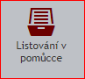
- This brings you to the index of the books in the Fond. The town names are in the small right panel in a red font.
- Choose your town from this list and click on it. In HBMa, you will find the records for Praha all the way at the bottom, after the towns starting with Z.
- All of the books from that town may or may not be displayed in the left panel. If they are not, you can scroll through those books one at a time by clicking on the double right triangle at the top of the left panel. 
- Click on the book you want. N=births, O=marriages, Z=deaths.
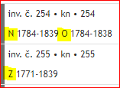
- Click on the image of the book at the right side of the panel. From here on, it will be just like using Badatelna.
- Suppose that you want to share a link to a page from one of these books with others. You cannot simply copy the URL at the top of the page, because that will not work for them. Instead, click on the button near the top of the screen with the picture of two chain links and copy the URL that will be shown in the dialog box. You will recognize that this is the right link by the word “permalink” in the middle of the URL.


What if your town isn’t in the list?

Type the name of your town in the search box and click on the magnifying glass.

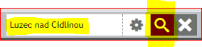
This will give you a list of hits with all of these words, not necessarily together. If you want only hits that have the words together exactly as typed in the search box, before clicking on the magnifying glass, click on the gear icon and on the words jako fráze.
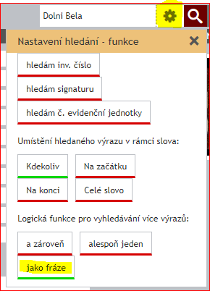
Then click on the magnifying glass. This is a useful device to know if your town name is a single word and that name appears too many times. For instance, instead of searching for Blansko, you could search for Blansko, o. Blansko with jako fráze selected. (Here, the second Blansko is the district name, which explains why you get so many hits when you just search for Blansko.)

When you are done investigating the books that resulted from your search, click on the X to the right of the magnifying glass to clear the search, so it doesn’t interfere with the next operation you do.

A Tip When Scrolling Through a Book on Vademecum

If you are scrolling through one of the record books, you will discover that you have to re-zoom in every time you move to a new page. Instead, if you have a magnification and page position (say, top left) that you like, click on the highlighted button that looks like an eye and then click on OK in the resulting dialog box.

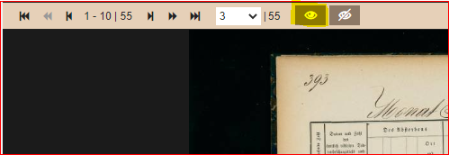
That will save your magnification and position on subsequent pages. You can cancel these preferences by clicking on the button next to the eye.

Explanation of Familiant records

Here is an explanation of the Familiant records, largely copied from https://yivoencyclopedia.org/article.aspx/Familiants_Laws and Section III of https://www.jewishgen.org/austriaczech/czechguide.html. In 1726, by order of the Habsburg emperor Charles VI, the number of Jewish families was limited to 8,541 in Bohemia, 5,106 in Moravia, and 119 in Silesia. (In 1787, Joseph II increased the totals to 8,600 in Bohemia and 5,400 in Moravia.) To enforce this quota, a so-called “Familianten” order was issued. According to this order, only the first-born son of each Jewish family could inherit the family permit to marry, upon reaching the age of 24. As long as the paternal grandfather was alive, the firstborn grandchild could not marry. The permit could be sold to another family if there was no son to inherit it. As a result, many Jews who could not obtain marriage permits emigrated from Bohemia and Moravia, or had illegitimate children, the latter undoubtedly defeating the purpose of the order.

The law of Francis I (Aug. 3, 1797) permitted Jews who had served as volunteers in the army or who lived exclusively by agriculture or by technical skill (nützliches Handwerk = useful trade) to marry without regard to the number of established families. They were allowed to marry, but were not familiants, so their firstborn sons could not inherit this privilege from them. It was not easy to use this route, because there was still a guild system, so a Christian master had to be found who accepted the Jewish boy into the apprenticeship. This was not cheap for the father of the boy and was hard work for the boy.

In 1848-1849 the Familianten order was abolished, partly reintroduced soon after, and only fully annulled in 1867.

A by-product of the Familianten order was that the government kept very good records of which Jewish families lived in which towns. Records were collected in 1799 and in 1811 and updated as long as the order was in effect. Each record contained the district name, registration number of the family, name of the father, his wife, his parents, his sons, and associated birth, marriage, and death dates. These records provide a very good resource for researchers investigating their family histories. For many families, multiple generations are included. One shortcoming of these records is that no daughters are listed, because only sons could inherit the marriage permit.

Here is an example of a Familiant record, from https://vademecum.nacr.cz/vademecum/permalink?xid=62da61fd-fe17-4117-b938-d0363b09d5eb&scan=0136cd80700f3607ba06acd571262312. This is the record of Moyses Oesterreicher, my ggg-grandfather from Česká Lípa, who married in 1802. It provides the names of his parents Joseph and Saara, his wife Esther Dub, and his 5 sons with their birth years. Moyses's oldest son Zacharias inherited the marriage permit in
1834 for his marriage. Zacharias's record is given on the same page, with his wife's name Magdalena Schreuer and their son Elias. By the time Elias married in 1861, the Familianten order was no longer in force, so the record was not further updated. Two daughters of Moyses and three daughters of Zacharias are nowhere mentioned on this page.

